EXPERIMENT 2

AIM: Numerical Simulation and Performance Analysis of Microwave Transmission Lines and Two-Port Networks Using Scattering Parameters
Objective 1:
To model coaxial, waveguide or microstrip transmission structures for microwave-frequency operation.
Objective 2:
To determine characteristic impedance, propagation constant and transmission characteristics of the selected structure.
Objective 3:
To obtain and analyze S₁₁, S₂₁, S₁₂ and S₂₂ over a specified frequency range.
Objective 4:
To evaluate return loss, insertion loss and transmission efficiency from the simulated S-parameter response.

Output:
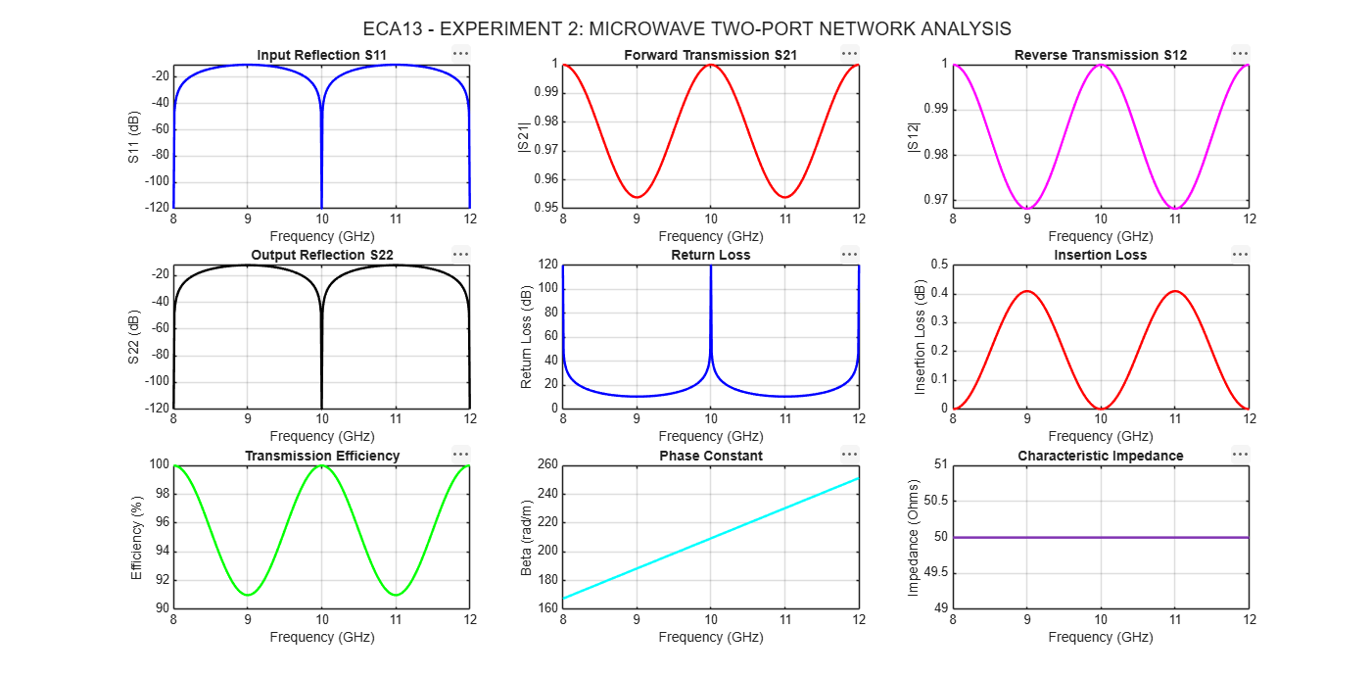

Input parameters
S.No. | Input Parameter | Symbol | Value
1 | Speed of Light | $$c$$ | $3×{10}^{8}$m/s
2 | Characteristic Impedance | $$Z_{0}$$ | 50 Ω
3 | Transmission Line Length | $$L$$ | 50 mm
4 | Center Frequency | $$f_{0}$$ | 10 GHz
5 | Starting Frequency | $$f_{min}$$ | 8 GHz
6 | Ending Frequency | $$f_{max}$$ | 12 GHz
7 | Frequency Step | $$Δf$$ | 10 MHz
8 | Number of Frequency Points | $$N$$ | 401

Result
The microwave transmission line was simulated over the frequency range of 8–12 GHz. The S-parameters, return loss, insertion loss, transmission efficiency, phase constant, and characteristic impedance were analyzed. The ideal matched, lossless model achieved 100% transmission efficiency with zero reflection.

